Cushioning Materials Testing Procedures
Establishing a Baseline Reading (Control)

1. Set up your ramp so that it matches your teacher’s setup using the flooring, track, brick, and binders or books. Make sure that your ramp is at the same angle and height as your teacher’s ramp.  2. Get the electrical plates and sticky tack. Place the sticky tack slightly below the middle of the electrical plates. Use sticky tack to put the electrical plates on the ends of the spring scale rods. Make sure the curved edges of the electrical plates (the backs) are facing towards the carts. | 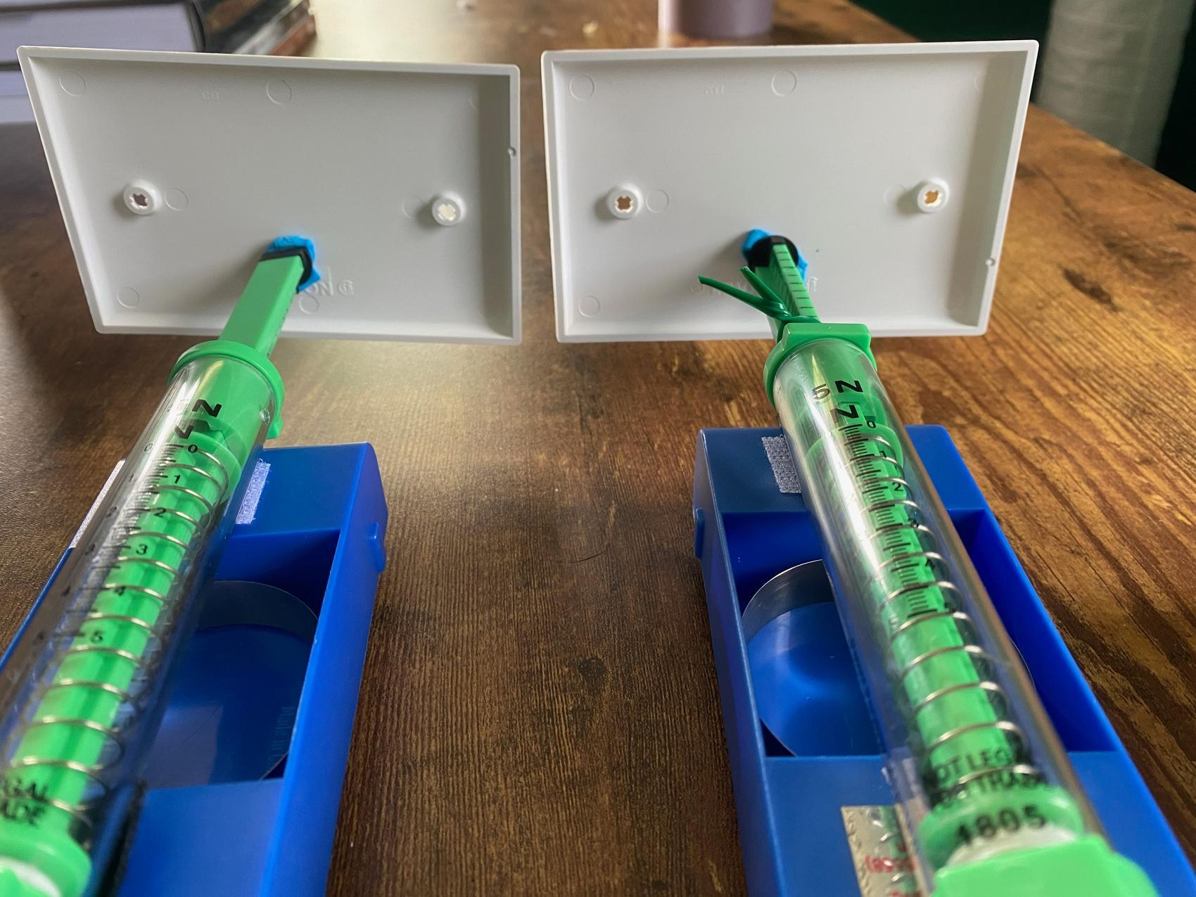
3. Using a scale, add clay to your carts until both carts weigh exactly 200 grams each.  4. Place your carts on the track. Bring the two carts together and make sure that the electrical plates are not touching the track as they move.  5. With the two carts together, adjust the electrical plates so that they are flat against each other with no big, visible gaps between them. Try to line up the edges and corners the best you can. | 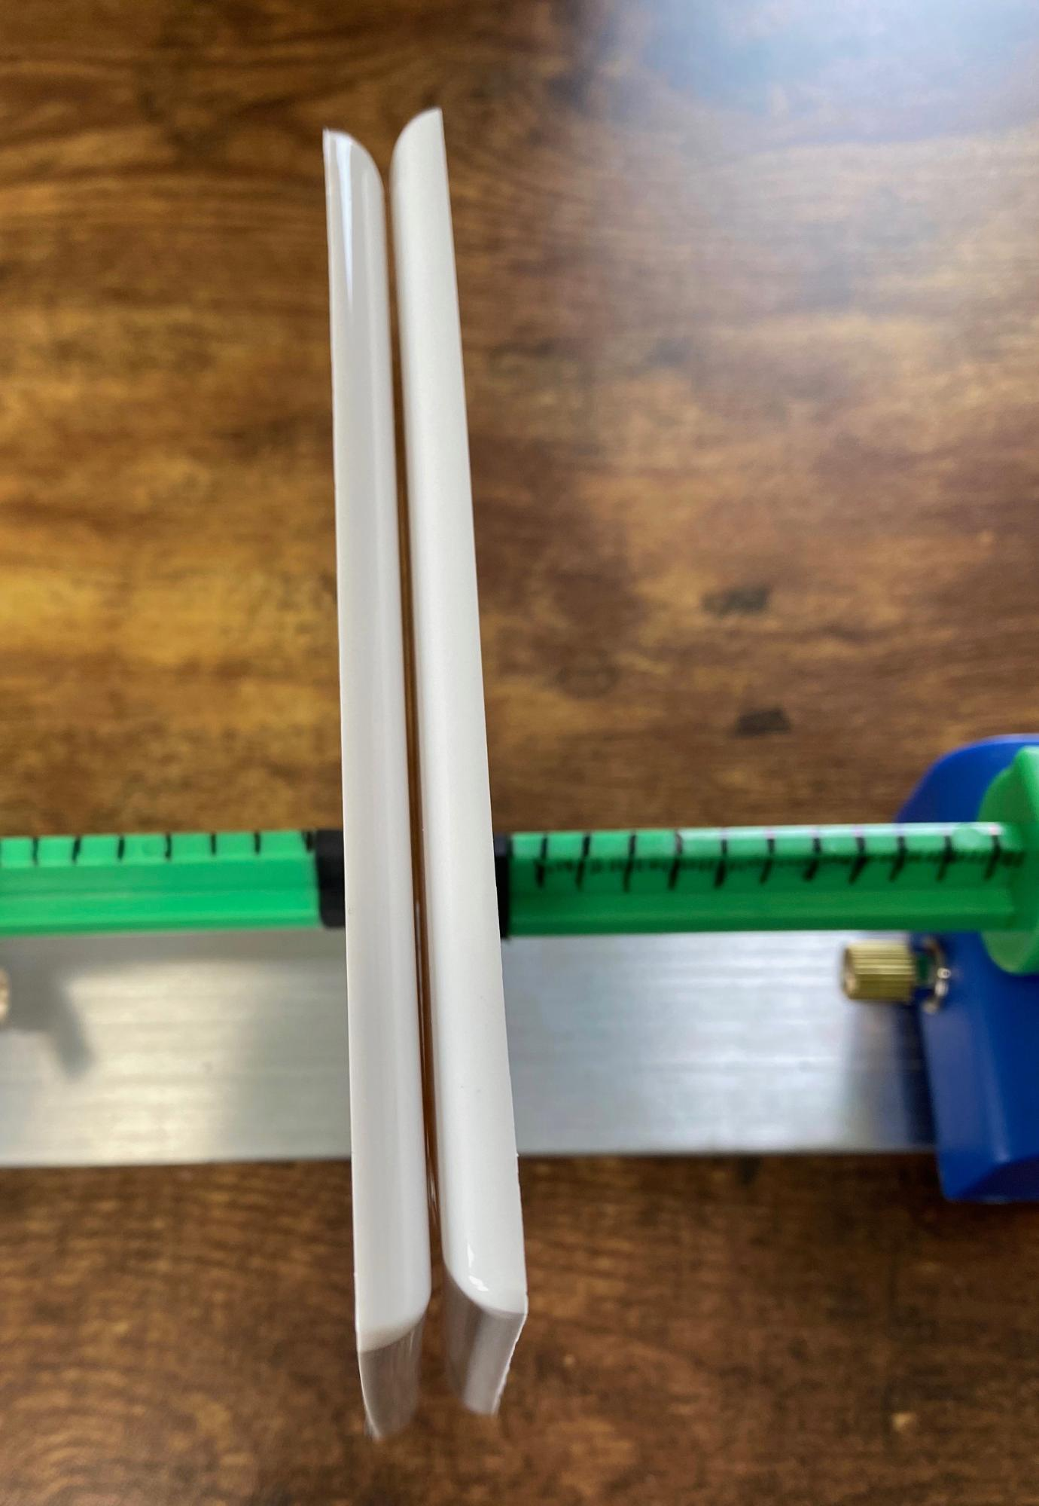
6. Place the cart with the twist tie collar near the bottom of the ramp with the electrical plate facing up the ramp. Tape the cart down about 4 inches from the bottom of the ramp. | 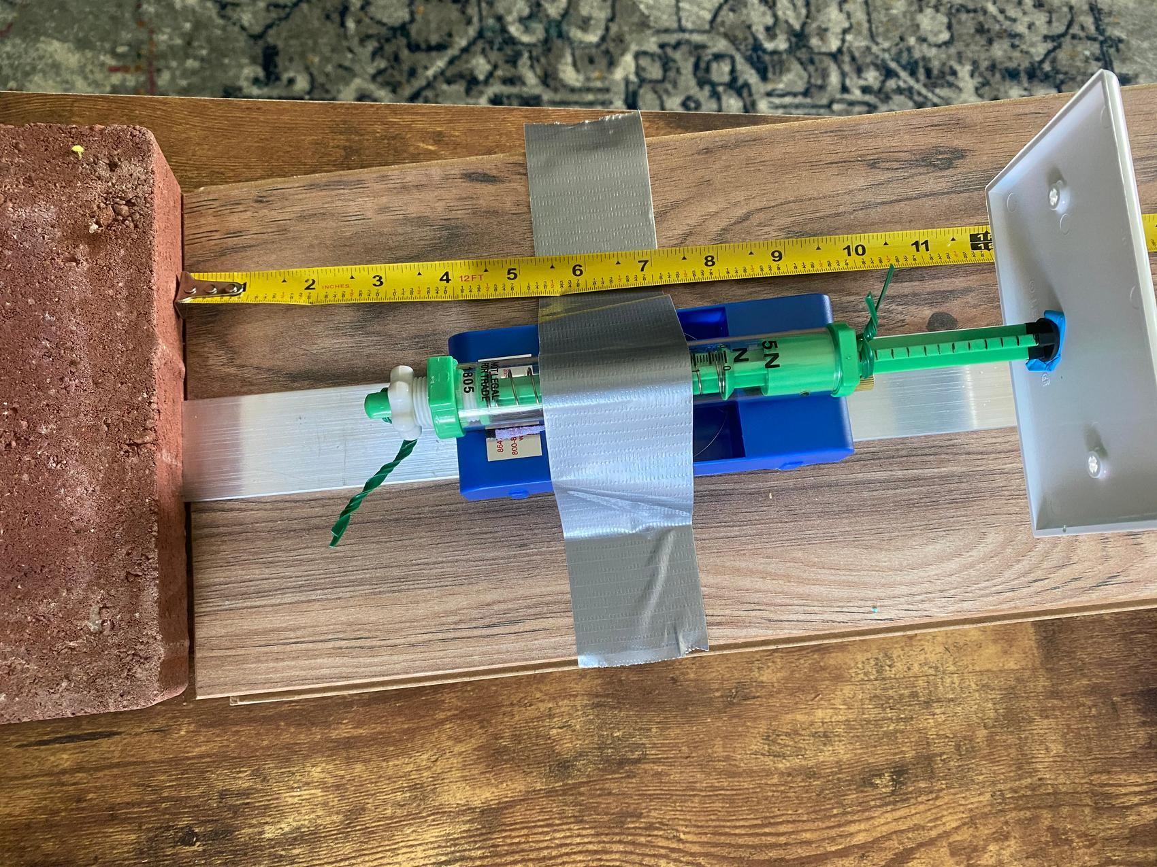
7. Confirm that the force collar is on the spring scale on the cart at the bottom of the ramp. Make sure that it is secure but can still easily move when the plunger is pushed in. Adjust the force collar on the scale so that it is at the base of the rod. | 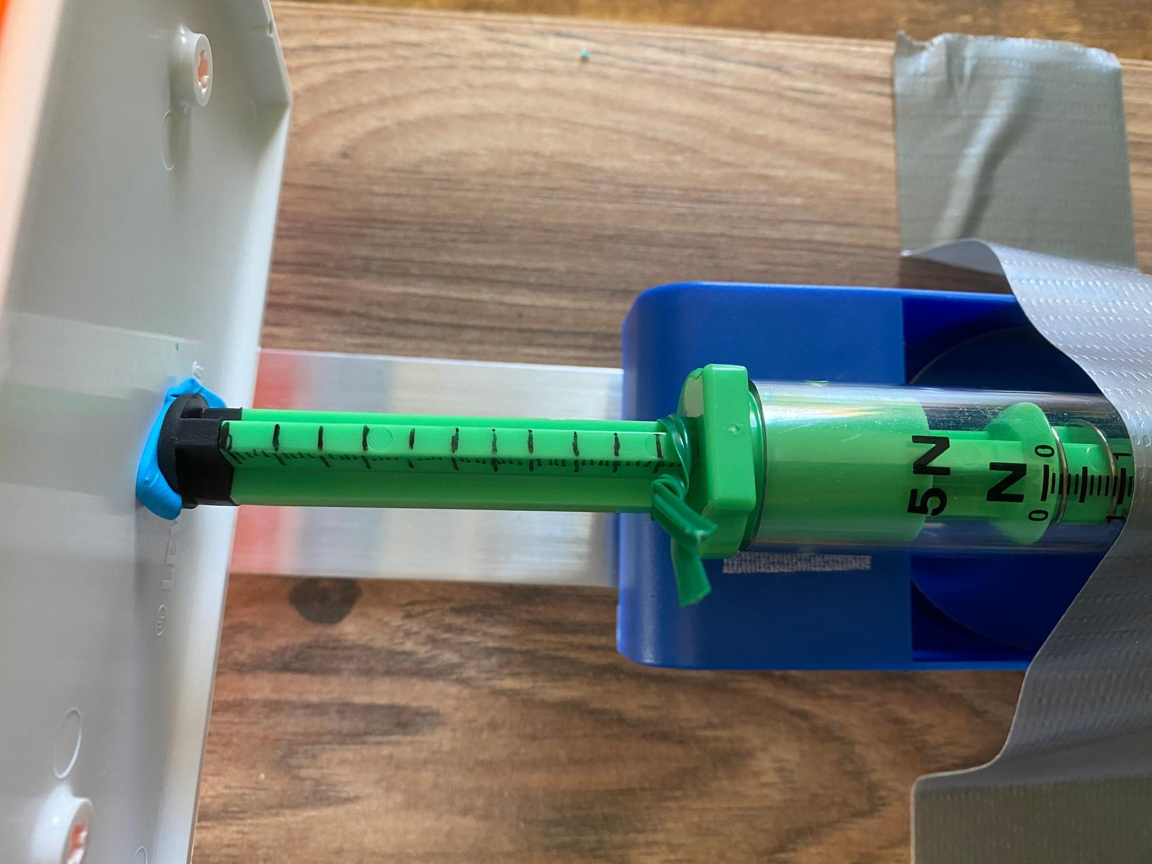
8. We need to establish a baseline reading so we can compare the peak force of the control collision with the peak force of the collision using a potential protective material. To do this, place the second cart at the top of the ramp with the electrical plate facing down the ramp. Release this cart towards the nonmoving cart at the bottom of the ramp.
9. Observe where the twist tie collar comes to rest on the rod on the spring scale. Record the data in the chart found at the end of this instruction set. Remember, each little line represents 1/10 of a newton. Each larger line represents 0.5 newtons. | 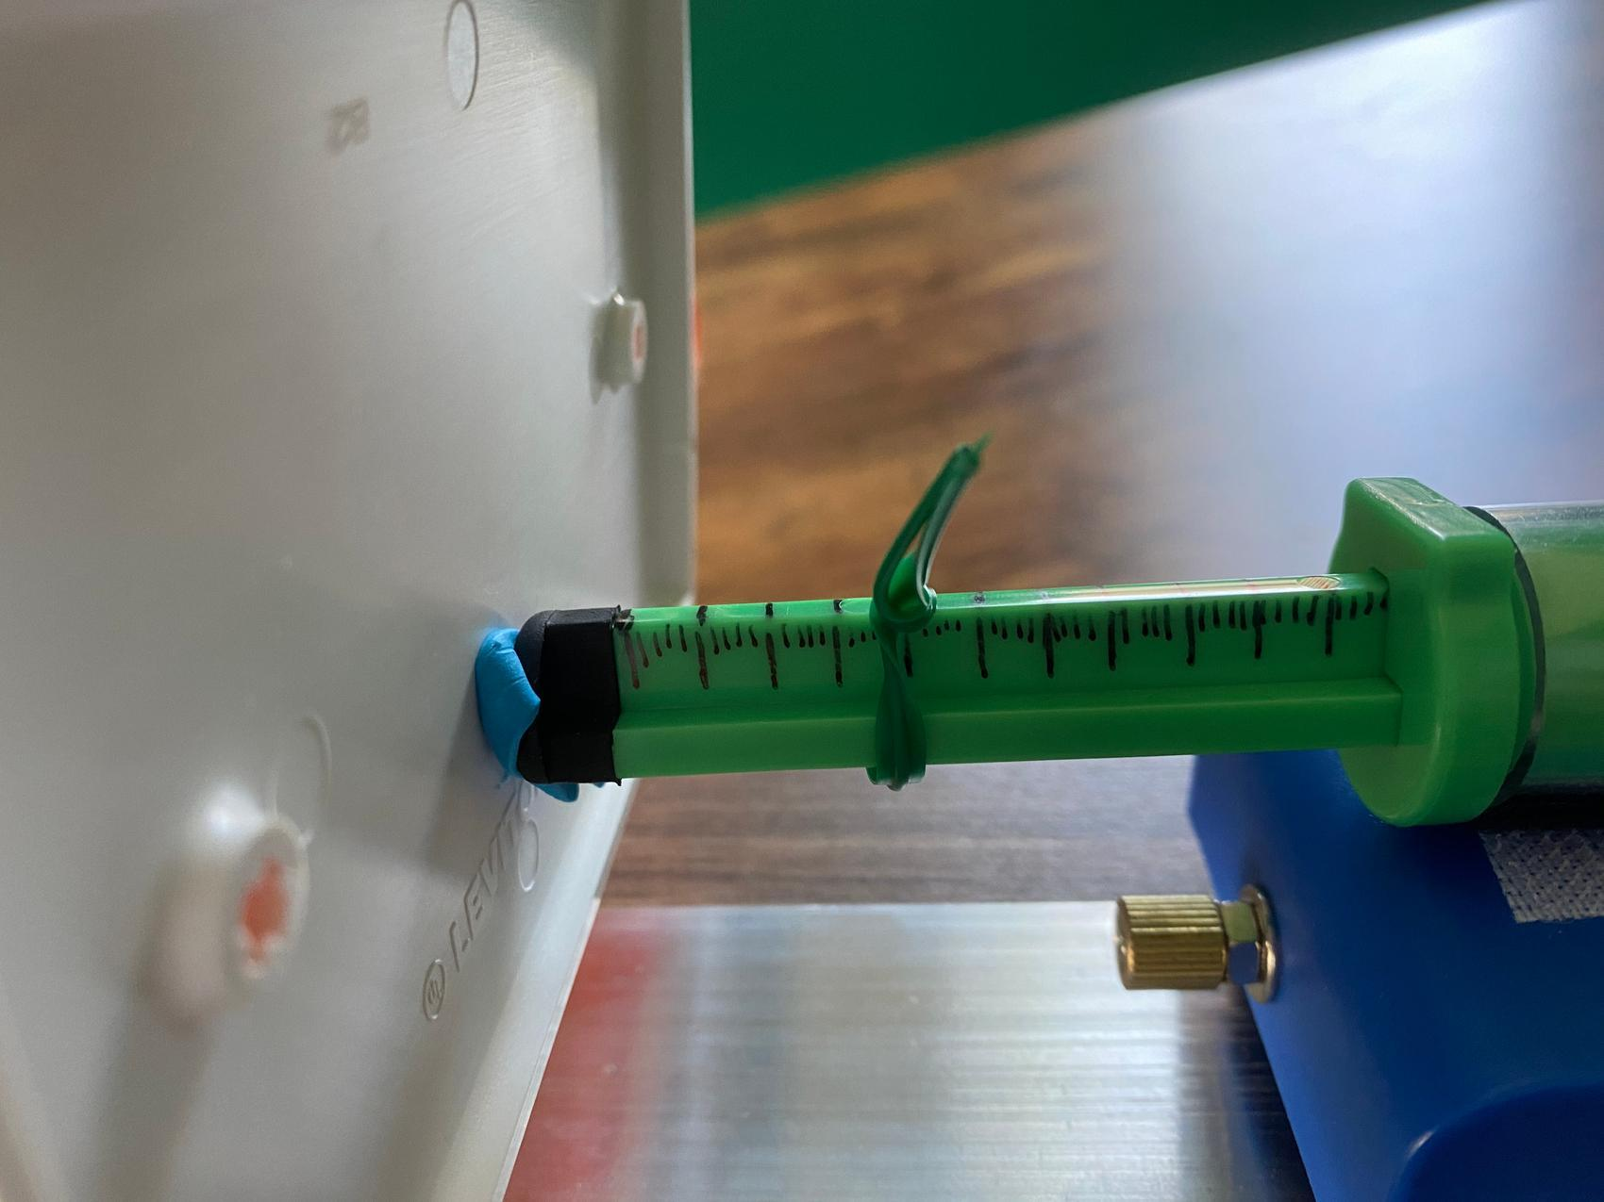
10. Run this test 5 more times using steps 7-9 to check the accuracy of the readings.
11. Find the average of the force collar readings at the bottom of the table.

Force Collar Readings without Potential Protective Material
Trial | Force collar reading (N)
1
2
3
4
5
6
Average reading

Testing a Protective Material (Experimental)

1. Place transparent tape circles on the back of the potential protective material you are testing. | 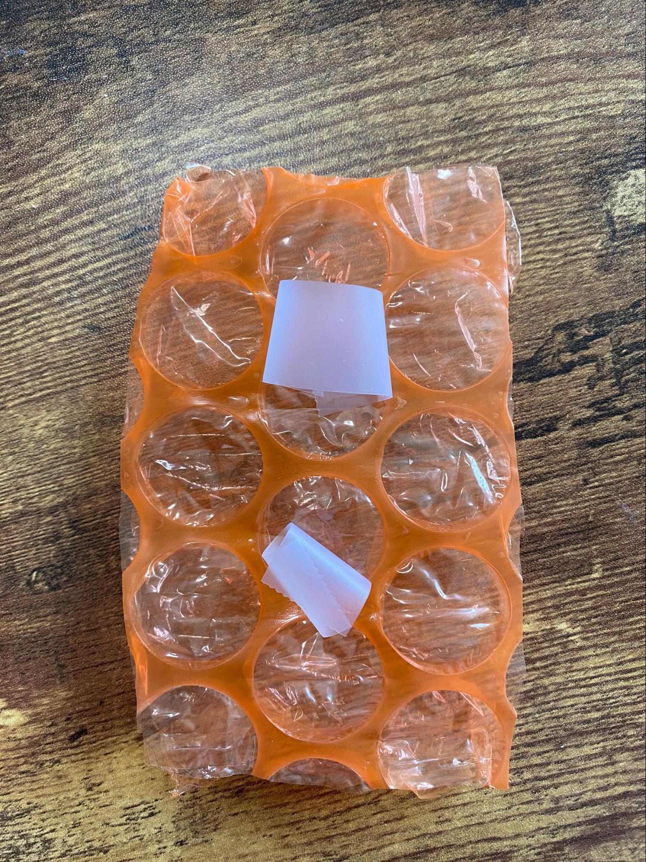
2. Tape the material to the front of the electrical plates on each cart. | 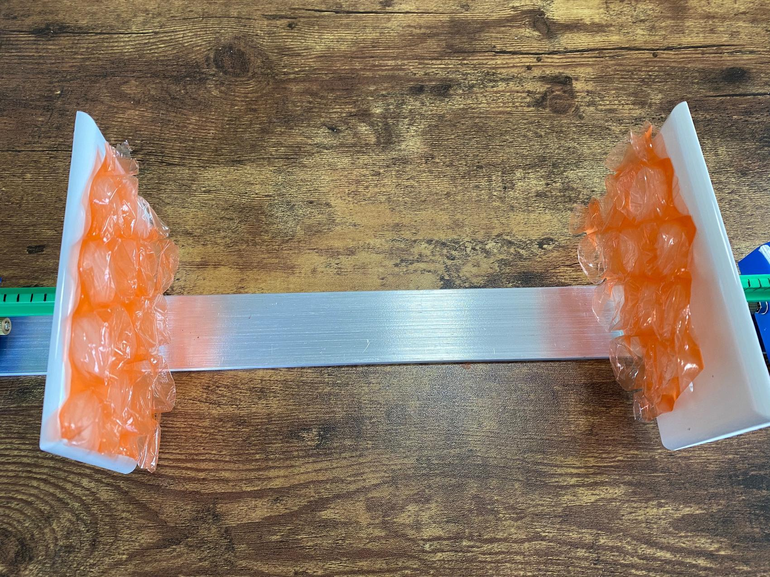
3. Using a scale and the clay, adjust the weight of the carts to 200 grams.
4. Make sure that the pieces of your material on the electrical plates on the two carts touch the best they can without any gaps when they are brought together. | 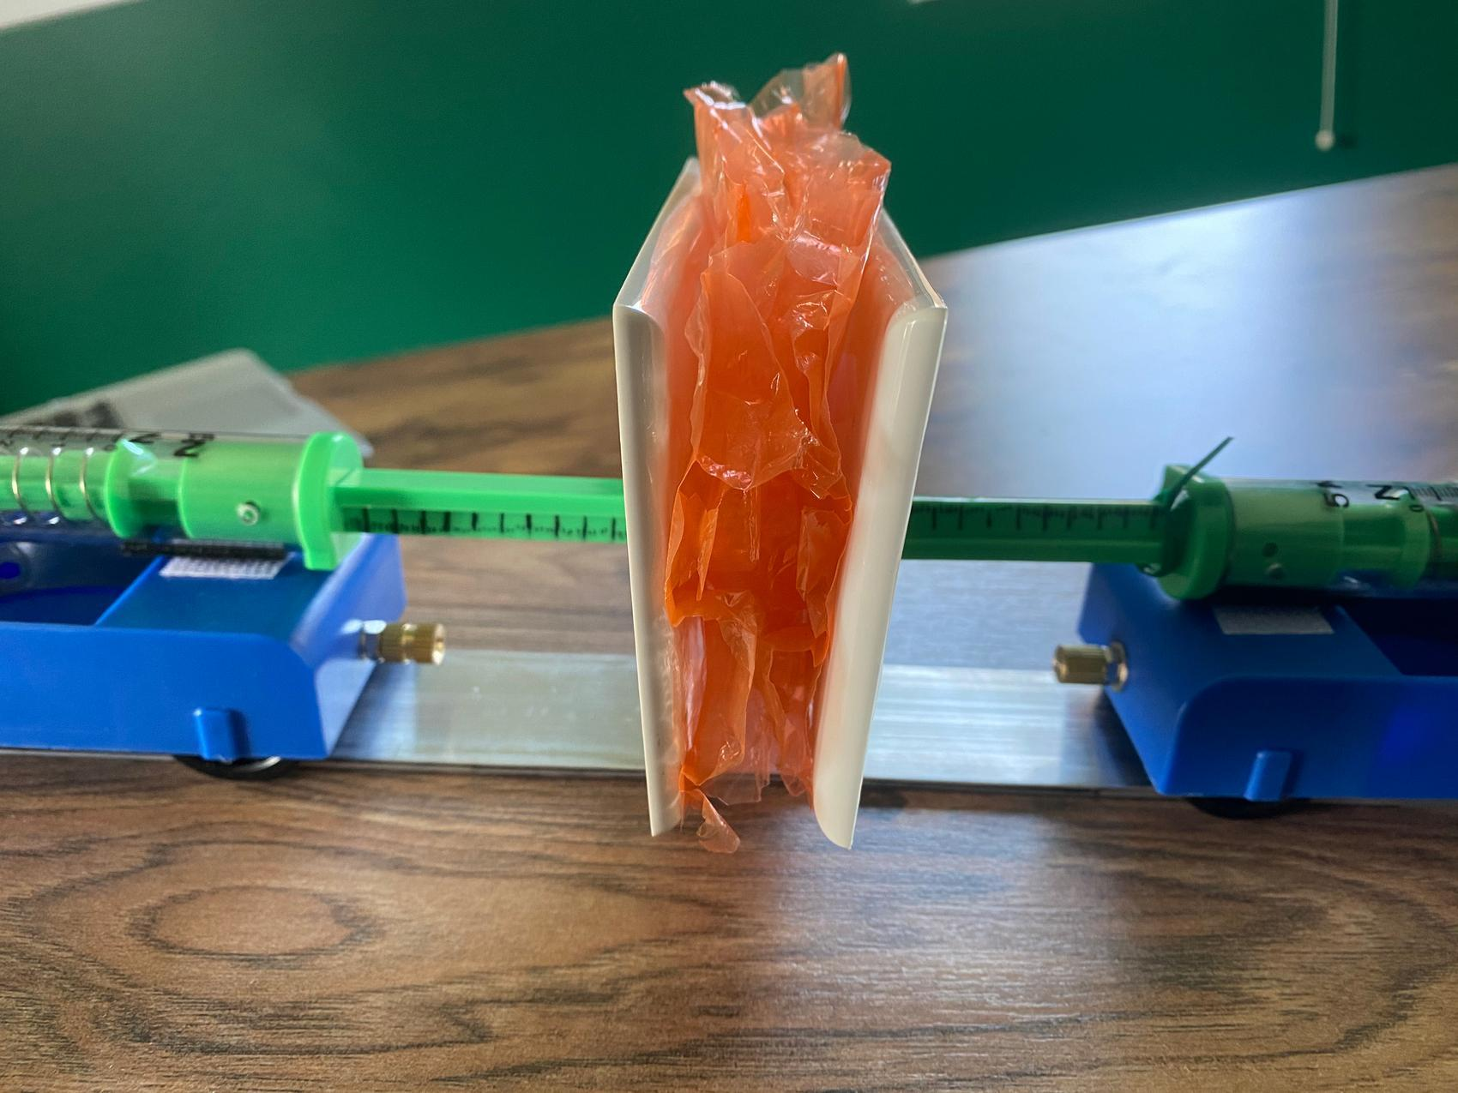
5. Adjust the force collar on the spring scale of the nonmoving cart so that it is at the base of the rod.
6. Place the colliding cart at the top of the ramp with the material facing down the ramp. Release the cart towards the nonmoving cart at the bottom of the ramp.
7. Record where the twist tie collar comes to rest on the chart found at the end of this instruction set. Each little line represents 1/10 of a newton. Each larger line represents 0.5 newtons.
8. Run this test 5 more times using steps 5-7 to check the accuracy of the readings.
9. Find the average of the force collar readings at the bottom of the table.

Force Collar Readings with Potential Protective Material
Trial | Force collar reading (N)
1
2
3
4
5
6
Average reading

Finding the Average Reduction in Peak Force
To figure out how well the material worked to reduce peak forces, we have to subtract the average force reading of the materials test from the average force of the control test without the materials.

average of test without materials |  | ________________ N
(subtract) -
average of test with materials |  | ________________ N
average amount of peak force reduction |  | ________________ N

The average peak force reduction of our material ____________________ is ______ newtons.

